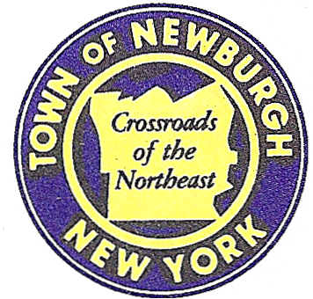

TOWN OF NEWBURGH
_______Crossroads of the Northeast __________________________
OLD TOWN HALL
308 GARDNERTOWN ROAD NEWBURGH, NEW YORK 12550

PLANNING BOARD
JOHN P. EWASUTYN, CHAIRMAN
TELEPHONE 845-564-7804
FAX 845-564-7802
E-MAIL: planningboard@townofnewburgh.org

PLANNING BOARD AGENDA

DECEMBER 4, 2014

*PLEASE NOTE: The Planning Board Meeting will start at 7:00 P.M. and all Applicants/Representatives
are to be present at that time. The Meeting will be held in the Meeting Room of Town Hall,
located at 1496 Route 300, Newburgh NY.*

- Huggins II (2014-23)  7 Todd Lane & 35 Cocoa Lane  Sec. 34; Blk. 2; Lots 24 & 90  Zone: R-2  Rep: Talcott Engineering  1 Gardnertown Road  Newburgh, NY 12550 | PUBLIC HEARING  SUBDIVISION AND LOT LINE CHANGE
- Sprint Nextel (2014-01)  39 North Plank Road (Mid Valley Mall)  Sec. 75; Blk. 1; Lot 11  Zone: B  Rep: Cara M. Bonomolo, Esq.  Snyder & Snyder, LLP  94 White Plain Road  Tarrytown, NY 10591 | WIRELESS TOWER UPGRADE  INITIAL APPEARANCE
- Elm Farm Subdivision (2000-09)  Wells Road & Fostertown Road  Sec. 39; Blk. 1; Lot 12.44  Zone: R-2  Rep: KC Engineering & Land Surveying  2142 Route 302  P.O. Box 42  Circleville, NY 10919 | 52 LOT SUBDIVISION - FINAL
- Petrick Timber Harvest (2014 -29)  178 North Fostertown Road  Sec.17; Blk.2; Lot 68  Zone: AR  Rep: Chris Prentis  Lower Hudson Forestry  P.O. Box 756 Nyack, NY 10960 | TIMBER HARVEST  CLEARING & GRADING  INITIAL APPEARANCE
- Webb Properties (2014-10)  Route 17K & Auto Park Place  Sec. 97; Blk. 2; Lots 35 & 43  Zone: IB  Rep: A. Diachishin & Associates  115 Yankee Folly Road  New Paltz, NY 12561 | SITE PLAN & LOT LINE CHANGE
- Hudson Valley Personnel Support Center of Jehovah’s Witnesses (2014-17)  1292 Route 300  Sec;97; Blk.2; Lots 30.1, 30.22 & 33  Zone IB  Rep: Dominic Cordisco Esq  Drake Loeb Heller, Kennedy, Gogerty, Gaba & Rodd PLLC  555 Hudson Valley Avenue  Suite 100  New Windsor, NY 12553 | SITE PLAN AND LOT CONSOLIDATION

*WORK SESSION: Project Readiness Discussion scheduled for 5:30 p.m. in the Meeting Room
of Town Hall on Thursday, December 4, 2014*

PLANNING BOARD BUSINESS
WORK SESSION

December 4, 2014
5:30 P.M.

Discussion:

- Longview Farm (2006-39): The Applicant is requesting a six month extension for the project from 14 December 2014 -14 June 2015.

